Power BI Assignment 2 – DAX & Data Visualization
Calculated Columns:
● Create a Calculated Column for 'Category Type':
Category Type = [category] & “-“&[Sub-Category]
● Calculate Revenue per Order in Order Details Table:
Revenue Per Order = [Amount]*[Quantity]
● Create a Calculated Column to Categorize Sales:
Sales Category =
IF(
[Amount]>Average(‘order details’[Amount]),
“Above Average”,
“Below Average”)

Calculated Measures:
● Calculate Order Count:
Order Count = DISTINCTCOUNT(‘Order details’[Order ID])
● Calculate Average Profit in Delhi:
Average Profit(Delhi) = CALCULATE(AVERAGE(‘Order details’[Profit]),’Order details[City] = “Delhi”)
● Calculate Year-to-Date (YTD) Sales:
YTD Sales = TOTALYTD(SUM(‘Ordrer details’[Amount]),’Order details’[Order date])

Data Visualization:

Sales Target Achievement by Category:

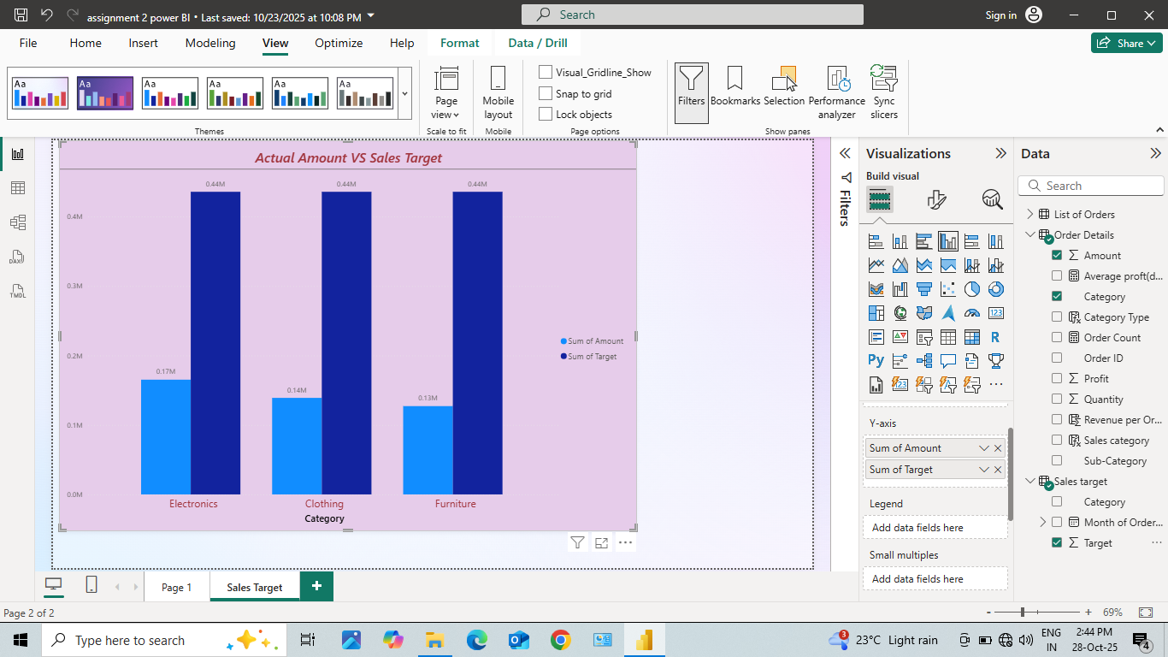

Max Profit Margin by Sub-Category:

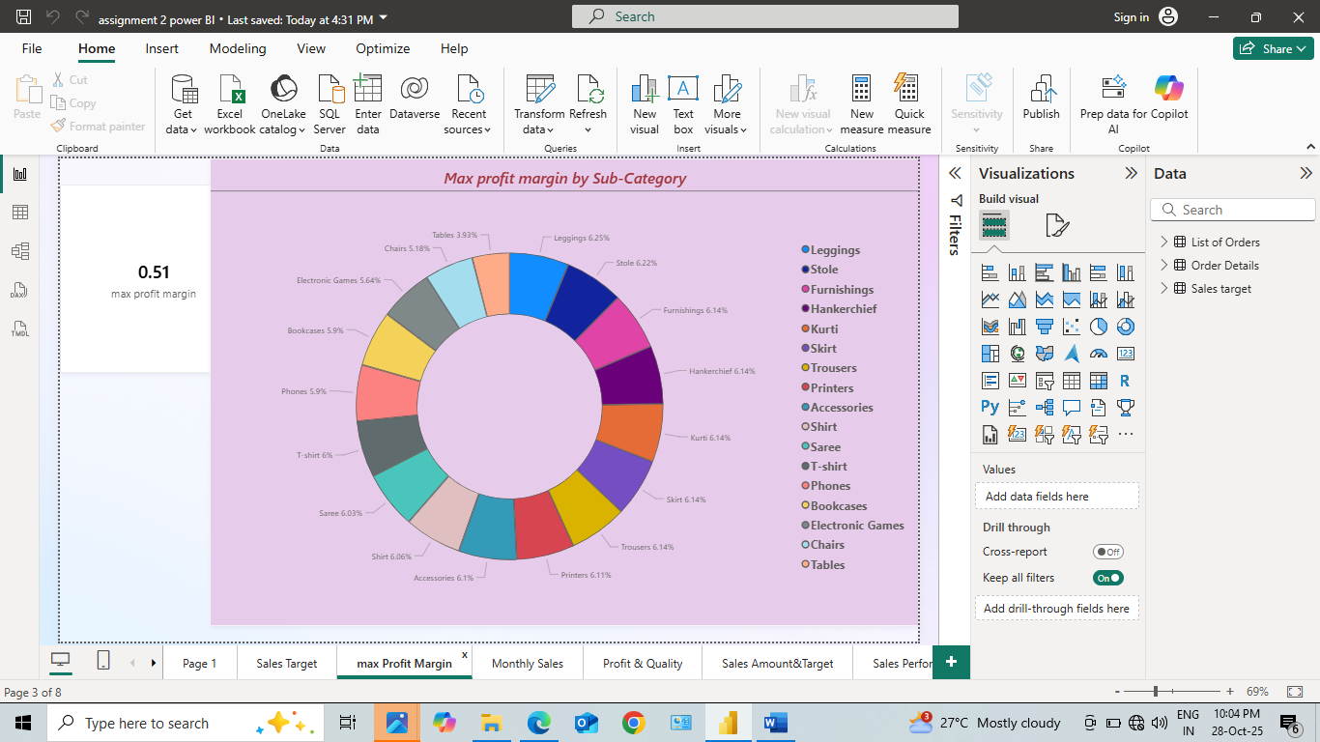

Monthly Sales Trend:

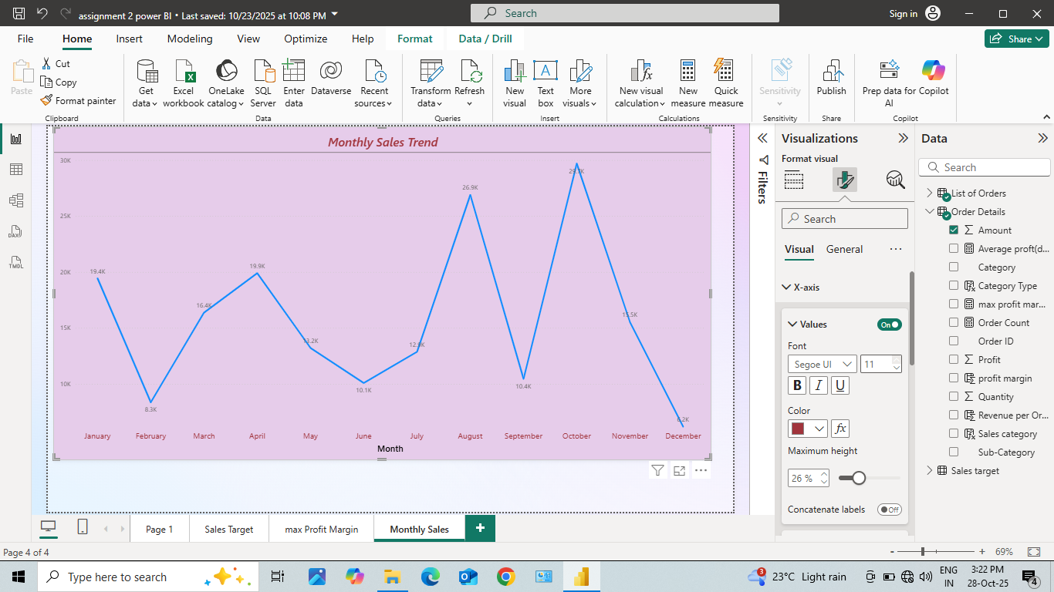

Comparison of Profit and Quantity by Sub-Category:

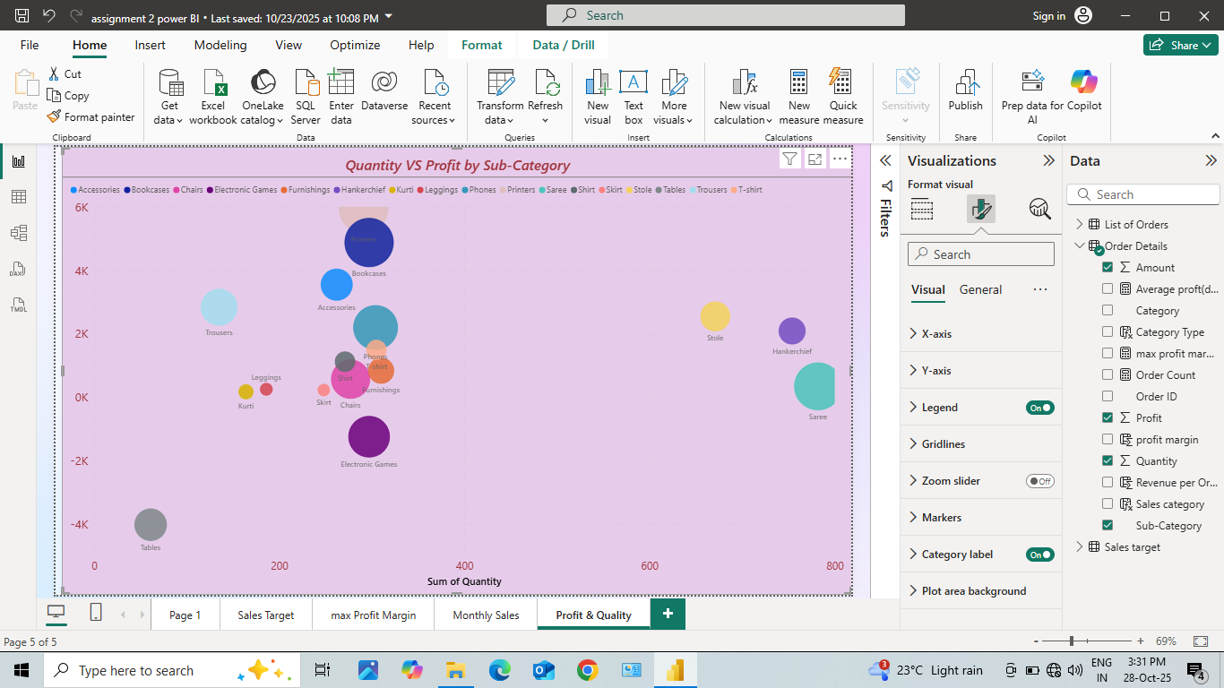

Comparison of Total Sales Amount and Target:

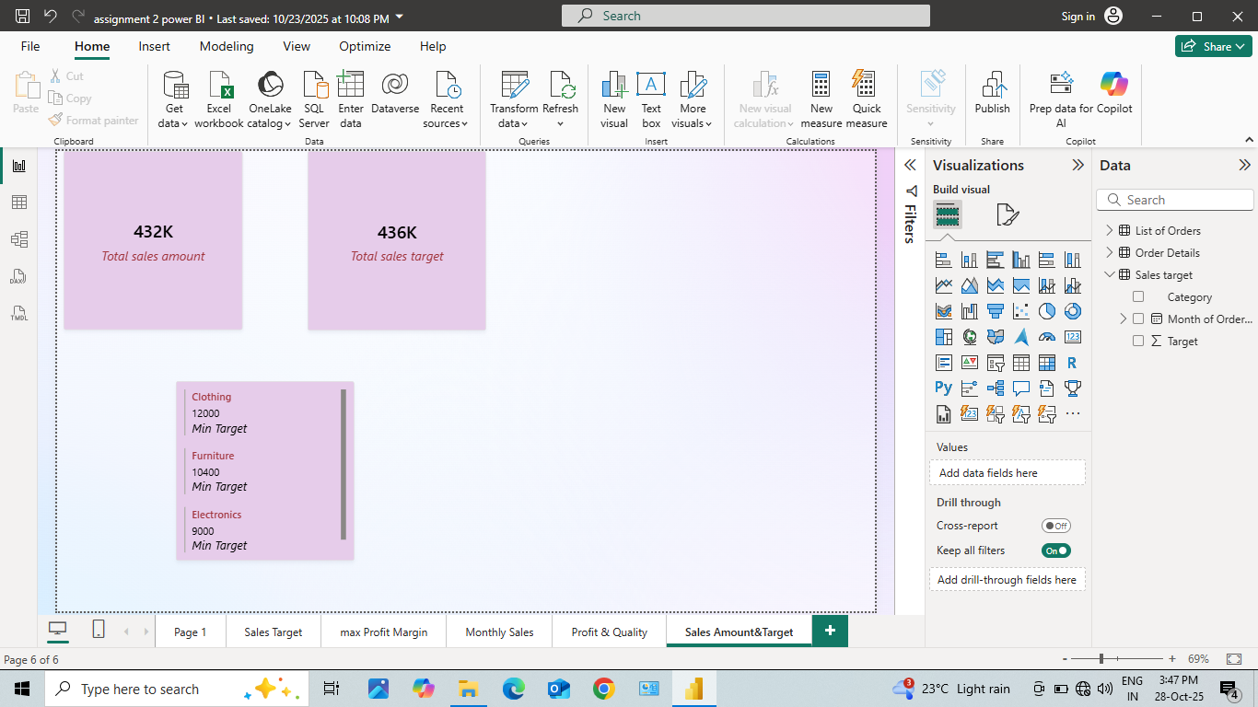

Sales Performance Matrix:

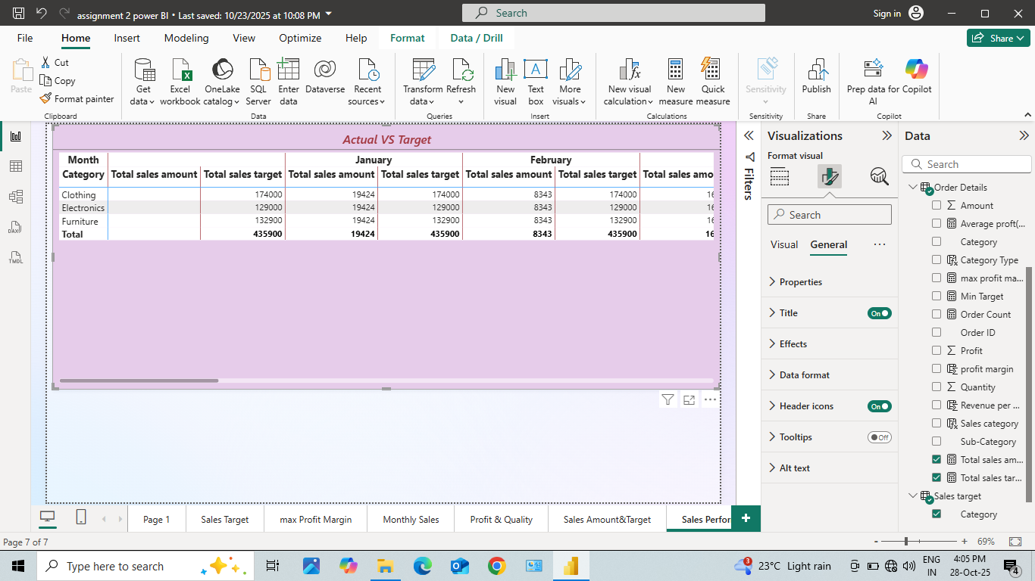

Geographic Sales Analysis:

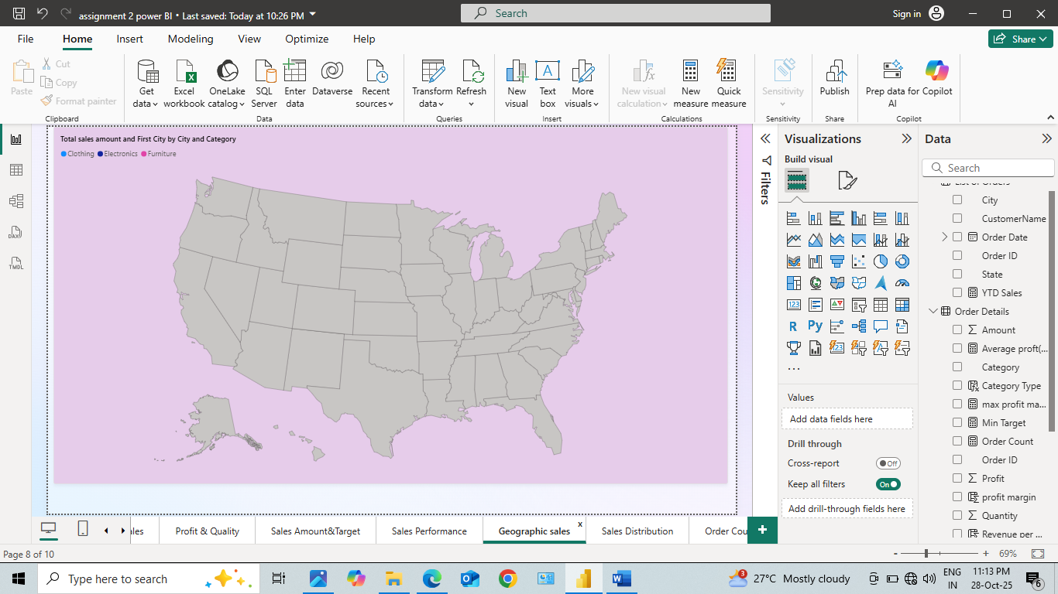

Sales Distribution by Sub-Category:

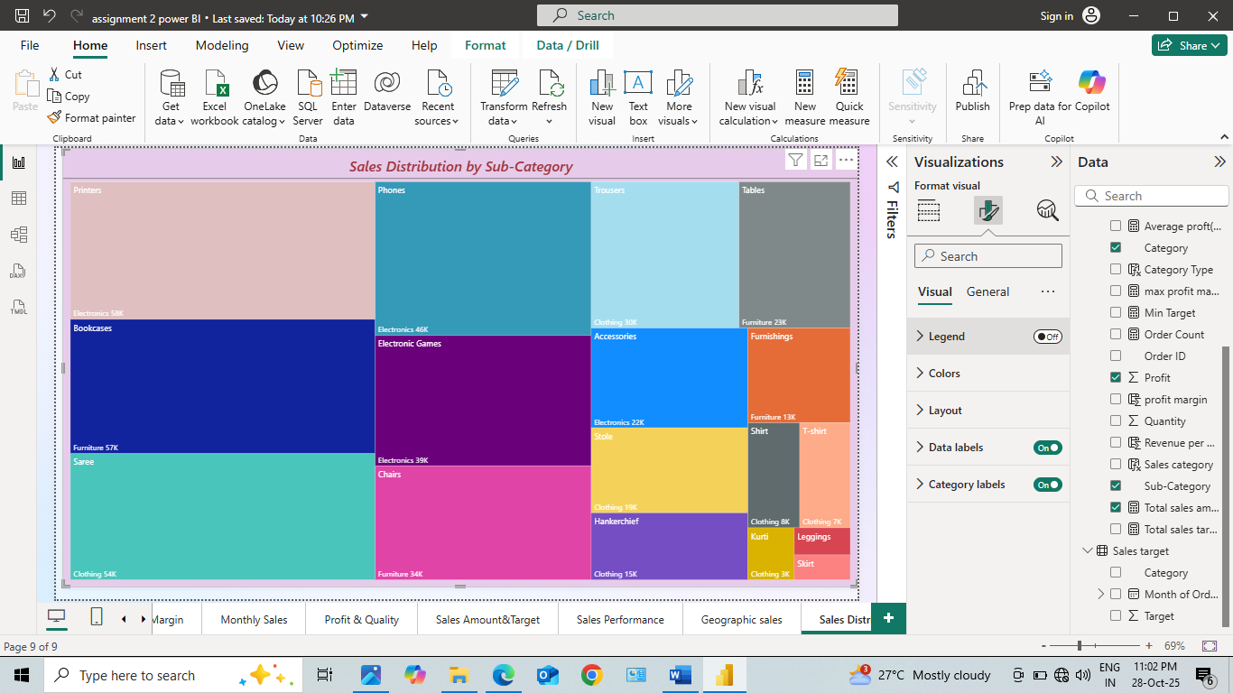

Order Count Analysis by State:

